Assignment 3: Monitor Unencrypted S3 Buckets Using AWS Lambda and Boto3

Objective
To detect Amazon S3 buckets that do not have server-side encryption enabled using AWS Lambda and Boto3.

Tools & Technologies Used
• AWS S3
• AWS Lambda
• IAM (Identity and Access Management)
• Python (Boto3 SDK)

Implementation Steps

1. S3 Bucket Setup

1. S3 Bucket Setup
- Multiple S3 buckets were created for testing.
- AWS automatically enables server-side encryption by default in new buckets.
- Therefore, all buckets had encryption enabled.
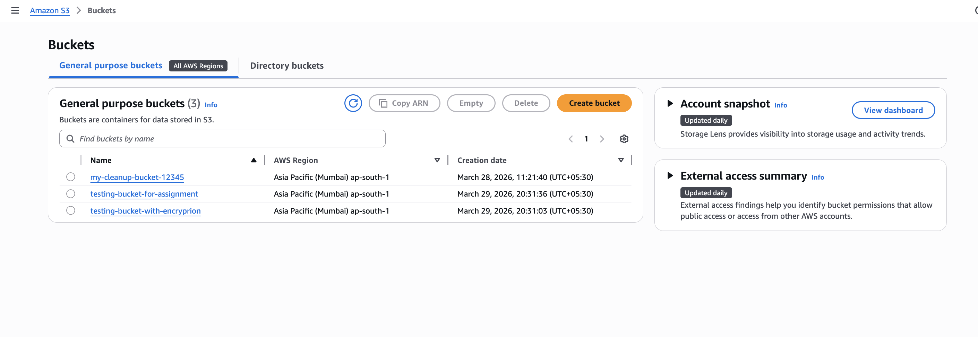

2. IAM Role Creation
• An IAM role was created for Lambda execution.
• The following policy was attached:
- AmazonS3ReadOnlyAccess

3. Lambda Function Creation
• A Lambda function was created using Python runtime.
• The IAM role was assigned to the function.
• The function uses Boto3 to check encryption status of S3 buckets.

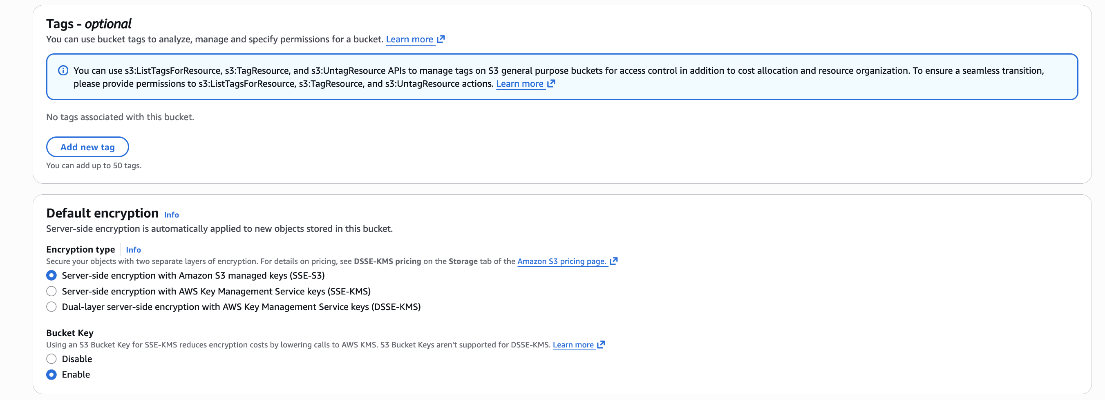

4. Lambda Function Code
import boto3
def lambda_handler(event, context):
s3 = boto3.client('s3')
response = s3.list_buckets()
unencrypted_buckets = []
for bucket in response['Buckets']:
bucket_name = bucket['Name']
try:
s3.get_bucket_encryption(Bucket=bucket_name)
print(f"{bucket_name} is encrypted")
except s3.exceptions.ClientError as e:
error_code = e.response['Error']['Code']

if error_code == 'ServerSideEncryptionConfigurationNotFoundError':
print(f"{bucket_name} is NOT encrypted")
unencrypted_buckets.append(bucket_name)
else:
print(f"Error checking {bucket_name}: {e}")

if unencrypted_buckets:
print("Unencrypted Buckets:")
for b in unencrypted_buckets:
print(b)
else:
print("All buckets are encrypted")

return {
'statusCode': 200,
'body': 'Check completed'
}

5. Testing and Results
• The Lambda function was executed manually.
• The logs were checked in CloudWatch.
• Output showed that all buckets are encrypted.
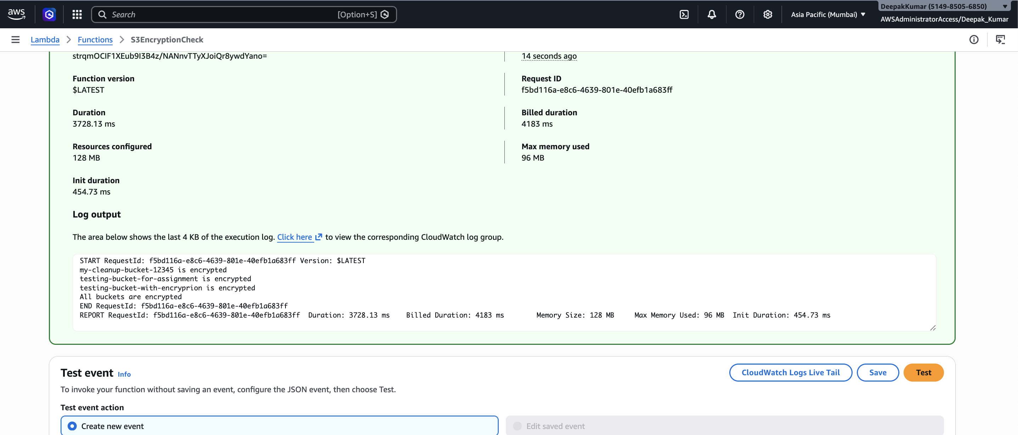

Conclusion
This assignment demonstrates how AWS Lambda and Boto3 can be used to monitor S3 bucket security.
Due to AWS security updates, server-side encryption is enabled by default for all new S3 buckets. Therefore, no unencrypted buckets were found during testing, indicating a secure configuration.

